NORDIC OPTICAL TELESCOPE

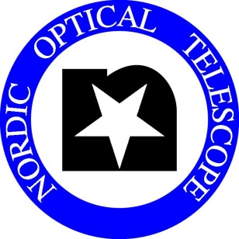

CALL FOR PROPOSALS

PERIOD 48: OCTOBER 1, 2013 – APRIL 1, 2014

The Nordic Optical Telescope (NOT) invites applications for observing time in Period 48, October 1, 2013 – April 1, 2014. The deadline for receipt of the applications is:
Thursday, May 2, 2013, at UT 12.00 noon.
Important Announcement:
Following ASTRONET’s recommendations on the future coordinated use of Europe's 2-4m telescopes, the Telescopio Nazionale Galileo (TNG) and NOT telescopes on La Palma have agreed to enter into a closer collaboration and begin to jointly offer time at both telescopes to both communities in the next semester. See further details at http://www.tng-not.iac.es/. Accordingly, Nordic scientists can now submit normal observing proposals directly to the TNG, and vice versa.

Note: Late applications are not accepted. However, proposals for short programmes (≤ 4 hours) using fixed instrument setups are welcome at any time (see http://www.not.iac.es/observing/service/ ).

Applicants should carefully read the following instructions:

1: Proposals for projects of all sizes are welcome, large and small as well as medium-size. Pooling of related and synergistic proposals by consortia of groups with similar interests is encouraged.
Programmes requiring one or more single-night periods may be executed in service mode on pre-assigned nights. Proposals should state whether or not service mode is desirable.
Applicants planning to propose Target-of-Opportunity or similar projects should contact the Head of Operations (tau@not.iac.es) in advance in order to discuss optimum strategies.

2: The proposal submission procedure is electronic. The Latex template and style files for Period 48 are available at the NOT web site: http://www.not.iac.es/observing/proposals/. Detailed instructions are provided in the template file itself and a README file; they should be followed carefully. Applicants should process and view the output of their files before submission in order to check that they process properly. Proposals using modified style files will not be accepted.
Proposals requesting more than one observing run in the period (using different instruments on a project counts as separate runs) should specify them individually in the proposal as indicated.

p.t.o.

3: Proposals should be submitted by e-mail before the above deadline to: proposal@not.iac.es, with the word "Proposal" both as Subject and as text. Automatic e-mail acknowledgement of receipt, with notification of any problems encountered in processing, is provided. Before the deadline, questions on proposal preparations or procedures may be sent to the same address with "Question" as the Subject.

4: Up-to-date information on instruments at NOT is found at http://www.not.iac.es/instruments/. Please note the following features for Period 48:
• The fiber-coupled échelle spectrograph FIES is always ready for use, also in parallel with other instruments. It offers superior stability and recent enhancements, e.g. an Atmospheric Dispersion Compensator (ADC), which can also be used with ALFOSC or NOTCam. We expect that a high-precision polarizer for FIES will become available in period 48.

5: Proposals are reviewed without regard to the nationality of the applicant(s), but eligible non-Nordic proposals should be submitted via the OPTICON programme if possible (see below), and the total time allocated to 'foreign' projects, including OPTICON time, will be limited to ~15% of the Nordic time. This limit does not apply to Italian projects submitted under the joint call described above.
Applicants will be informed of the outcome of their proposal as soon as possible after the evaluation by the NOT Observing Programmes Committee and preparation of the observing schedule by the Director. Brief explanatory notes are provided to proposers, especially for rejected proposals. Note also that only 75% of the science time can be scheduled by NOTSA; the rest is Spanish time. Awards of observing time do not imply any other financial support from NOT.

6: The OPTICON Trans-National Access Programme provides access for external users to NOT and several other European telescopes with support from the European Union. NB: Proposals for OPTICON time are submitted and reviewed separately two months before the normal NOT proposals, and all eligible non-Nordic applicants should follow the OPTICON procedure. See http://www.astro-opticon.org/fp7/tna/ for the next deadline and all details on this programme.

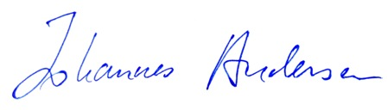

March 31, 2013 J. Andersen

Director, NOTSA

