NORDIC OPTICAL TELESCOPE

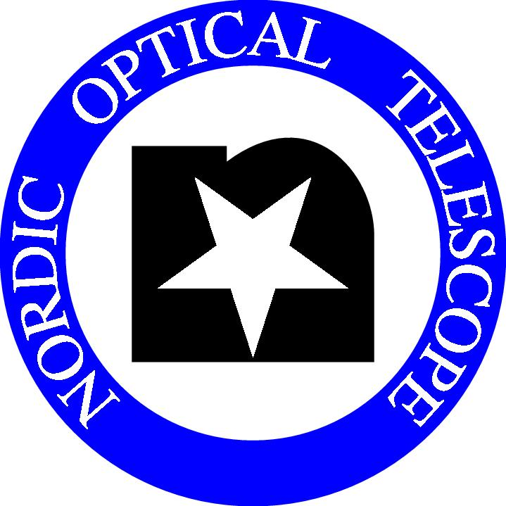

CALL FOR PROPOSALS

PERIOD 46: OCTOBER 1, 2012 – APRIL 1, 2013

The Nordic Optical Telescope (NOT) invites applications for observing time in Period 46, October 1, 2012 – April 1, 2013. The deadline for receipt of the applications is:
Wednesday, May 2, 2012, at UT 12.00 noon.
Note 1: The legal and financial conditions for the continued operation of the NOT are currently being discussed. Time allocations in Period 46 will depend on a satisfactory solution to these issues.
Note 2: Late applications are not accepted. However, proposals for short programmes (≤ 4 hours) using fixed instrument setups are welcome at any time (see http://www.not.iac.es/observing/service/ ).

Applicants should carefully read the following instructions:

1: Proposals for projects of all sizes are welcome, large and small as well as medium-size. Pooling of related and synergistic proposals by consortia of groups with similar interests is encouraged.
Observations are increasingly executed in service mode on pre-assigned nights. Proposals should state if service mode is not desirable.
Applicants planning to propose Target-of-Opportunity or similar projects should contact the Head of Operations (tau@not.iac.es) in advance in order to discuss optimum strategies.

2: The proposal submission procedure is electronic. The Latex template and style files for Period 46 are available at the NOT web site: http://www.not.iac.es/observing/proposals/. Detailed instructions are provided in the template file itself and a README file; they should be followed carefully. Applicants should process and view the output of their files before submission in order to check that they process properly. Proposals using modified style files will not be accepted.
Proposals requesting more than one observing run in the period (using different instruments on a project counts as separate runs) should specify them individually in the proposal as indicated.

3: Proposals should be submitted by e-mail before the above deadline to: proposal@not.iac.es, with the word "Proposal" both as Subject and as text. Automatic e-mail acknowledgement of receipt, with notification of any problems encountered in processing, is provided. Before the deadline, questions on proposal preparations or procedures may be sent to the same address with "Question" as the Subject.

p.t.o.

4: Up-to-date information on instruments at NOT is found at http://www.not.iac.es/instruments/. Please note the following features for Period 46:
• A Wedged Double Wollaston Prism, on loan from Asiago Observatory, Italy, is available for one-shot polarimetric imaging observations with ALFOSC.
• The fiber-coupled échelle spectrograph FIES is permanently available, also together with other instruments. It offers superior stability and many recent enhancements, including an Atmospheric Dispersion Compensator (ADC), which can also be used with ALFOSC or NOTCam. We expect that a high-precision polarizer for FIES will become available in period 46; when the polarizer has been fully tested the SOFIN spectrograph will be decommissioned.
• The near-infrared instrument NOTCam offers new filters for the Y and Z bands; both are included in the Exposure Time Calculator. The Z filter currently shows a high background, which is being investigated. See our web site for details.

5: Proposals are reviewed without regard to the nationality of the applicant(s), but eligible non-Nordic proposals should be submitted via the OPTICON programme if possible (see below), and the total time allocated to 'foreign' projects, including OPTICON time, will be limited to ~15% of the Nordic time. Note also that only 75% of the science time can be scheduled by NOTSA; the rest is Spanish and CCI International Time. Award of observing time does not imply any financial support from NOT.
Applicants will be informed of the outcome of their proposal as soon as possible after the evaluation by the NOT Observing Programmes Committee and preparation of the observing schedule by the Director. Brief explanatory notes are provided to proposers, especially for rejected proposals.

6: The OPTICON Trans-National Access Programme will provide access for external users to NOT and several other European telescopes with support from the European Commission, provided that a new contract is approved by the European Commission (TBC at the present time). NB: Proposals for OPTICON time are submitted and reviewed separately two months before the normal NOT proposals, and all eligible non-Nordic applicants should follow the OPTICON procedure. See http://www.ing.iac.es/opticon/ for the next proposal deadline and all other details on this programme.

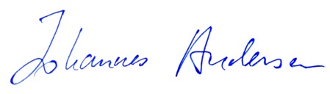

April 1, 2012 J. Andersen

Director, NOTSA

